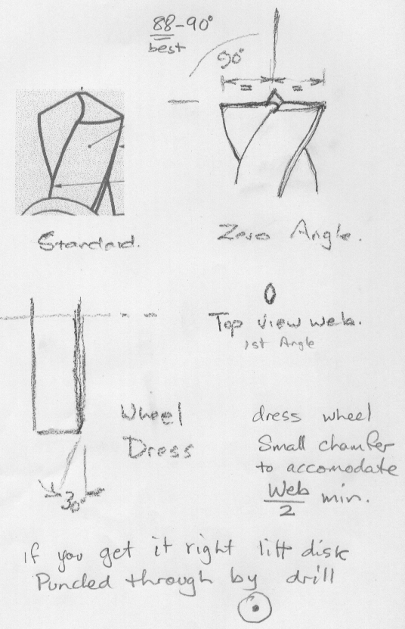

First step in grinding the drill is to dress the corner of the wheel 30⁰ as shown.
Sharpen the drill so that the axis of the drill lines up with the edge of the wheel. For thin sheet drilling, the angle is better at 88⁰ that way the edges of the hole break through first.
If you sharpen this way don’t center punch or pilot drill, just mark the center, the web of the drill actually cuts.
For Aluminium, keep the lip clearance to a minimum, and make sure the lip lengths are equal.

